Name  of Municipality | Novoarkhangelsk village community
Mayor | Yurii Shamanovskyi
Location | Ukraine, Novoarkhangelsk, Kirovograd Region, Ukraine
Population | As of 01.01.2022, there are 13 006 persons.
Short overview  (1-5 sentences) | Novoarkhangelsk village community consists of the village of Novoarkhangelsk and twenty more villages. The total area of the community is 492,3 km². Novoarkhangelsk has a well-developed transport infrastructure such as bus connection with all regions of the country and Poland. The village is located near the M-12 highway (Stryy - Ternopil - Kropyvnytskyi - Znamyanka (via the city of Vinnytsia), which coincides with the European highway E-30. Many important monuments were discovered in Novoarkhangelsk and neighboring villages, from the Late Paleolithic to the Middle Ages. The main one is the medieval Golden Horde city on the territory of the village Torgovytsia.  Since the 24 of February 2022, Novoarkhangelsk village community accepted up to 1,600 people for temporary residence who suffered as a result of the brutal war of the russian federation against Ukraine.
Website | https://novoarhangelska-gromada.gov.ua/
Expertise/Expert knowledge in some fields  (Example Energy, Water, Education, Technology etc.) | Novoarkhangelsk village community pays considerable attention to the agricultural sector. Our community has 40613.87 hectares of agricultural land. There are 76 farms (agricultural enterprises) operating in the community. There are farms that grow grain and technical crops. Also, some farms are engaged in horticulture and gardening. Several farms are engaged in animal breeding. Іn the community there is a dairy farm with the prospect of building a mini-dairy factory. There are also 3 operating elevators for 36 thousand tons of grain.
Desired areas of future cooperation with EU municipality | - Economic activities. There are a lot of possibilities for business rendering within the community, which has such sources as working potential and raw materials, as well as comfortable transport routes. We are interested in strong cooperation in the field of the latest technologies, cultivation, exchange of crop varieties, technical support of agricultural activities and animal breeding.  - Tourism. Starting from 2021, the Novoarkhangelsk territorial community began an active study of the history of the Battle of the Blue Waters, which probably took place on the territory of our community in 1362. In 2021, the first children's historical and cultural festival "Blue Waters Fest" was held, which was dedicated to this historical event and was accompanied by the reconstruction of the battle with the participation of the "Aina Bera" fighting club. We are in need for creative ideas of ideas for holding children's festivals on historical topics, as well as financial support for this event.
Contact person  E-Mail:  Telefon: | Liudmyla Sydorenko  viddileconomik@ukr.net  +380681675124
Language for communication | Ukrainian, English
Photos of municipality | 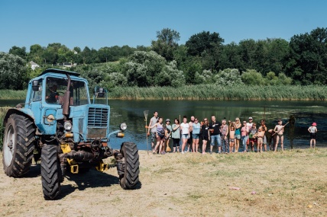 At this photo you can see the members of the eco-movement who gathered to clean up the beach area, including community residents and internally displaced persons.  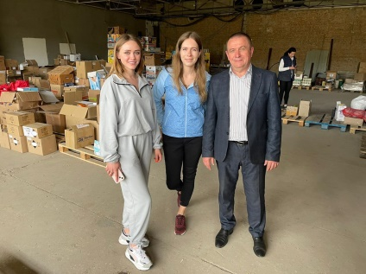 The Mayor Yurii Shamanovskyi with volonteers, who help with humanitarian aid.

