Name  of Municipality | Podilsk City Territorial Community
Mayor | Oleg Albanskyi
Location | Ukraine, Odesa Region
Population | As of 01.01.2021, there are 42779 persons.  The population of the working age in the community consists of 25,935 people.
Short overview  (1-5 sentences) | Podilsk city territorial community consists of the city of Podilsk and the villages of Lypetske, Oleksandrivka and Kazbeky. The total area of the community is 4,762.33 hectares.  The community has convenient transport connections. Thus, on the territory of the city of Podilsk there are: a railway station “Podilsk”, a highway of regional importance R-33 which connects with highways of the international importance. The distance from the city of Podilsk to the State Enterprise “Odesa Sea Commercial Port” is 225 km, to the international airport “Odesa” – 196 km, to the airport “Chisinau” – 122 km.  On 24 February 2022, the first day of Russia's armed aggression against Ukraine, the Podilsk city territorial community suffered losses. Enemy missile destroyed military unit A-0173, killing 22 servicemen.
Website | https://podilska-gromada.gov.ua/
Expertise/Expert knowledge in some fields  (Example Energy, Water, Education, Technology etc.) | There is the industrial park “Podilsk”, the area of which takes 31.0704 hectares. Priority areas of economic activity that can be carried out in the industrial park, are processing industry: primary and secondary processing of agricultural raw materials, food production, etc.  There is “Podilsk Vocational Lyceum” State Educational Institution in Podilsk, which trains personnel in the following professions: tractor driver, electrician, cook, baker and builder, and there is also Regional Municipal Institution “Podilsk Medical Vocational College named after V.O. Zhykovskyi”, which provides highly qualified medical staff.  Agricultural lands within the settlements take 2,021.46 hectares. According to the State Land Cadastre, 9,077.4464 hectares of lands were inventoried (with cadastral numbers) outside the Podilsk city territorial community.  The priority of agricultural activity is growing crops (sunflower, corn, wheat, barley, etc.). However, in the territory of the Podilsk city territorial community the activity on processing of the given cultures and production of foodstuff is poorly developed that can be an attractive for businessmen from the potential sister city.
Desired areas of future cooperation with EU municipality | - Education. It is possible to organize academic mobility in the form of study tours of students, as well as referrals to practice.  - Economic activities. There are a lot of possibilities for business rendering within the community, which has such sources as working potential and raw materials, as well as comfortable transport routes.  - Tourism. There is a unique Underground Monastery in the village of Kazbeky, built in the early twentieth century by adherents of the religious movement of Inochentism. According to the scheme that has been preserved, the area of ​​the monastery is about 30 hectares. Some corridors reach 2.5 km in length. The monastery had at least 80 cells, various warehouses and offices, including a wine cellar, as well as three churches, the largest of which had a vault 15 meters high. This monument is currently in a state of emergency and requires significant funds for restoration.
Contact person  E-Mail:  Telefon: | Iryna Radkovska  investpodilsk@gmail.com  +380992589348
Language for communication | English
Photo of municipality view | 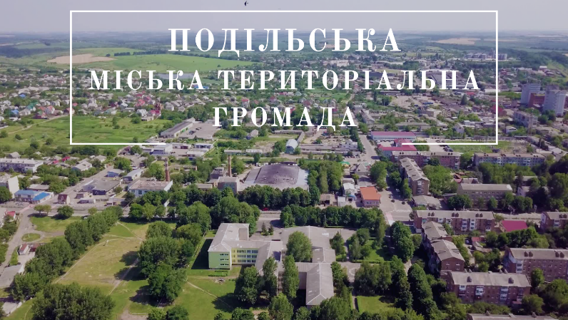

Millennialist and Charismatic Christian sect, split from mainstream Eastern Orthodoxy in the early 20th century.

